NOTICE
RPAT BE Sem – 1 & 2, October – 2020

The remedial exams for the all the subjects of BE – 1 and BE – 2 will start from 26th October, 2020.
The students will have to register for the subjects in which they wish to appear for remedial exam. To register for this remedial exam open the link given below (or scan the given QR code) and follow the instructions.
https://forms.gle/ayKXfm1CEzK36pv9A
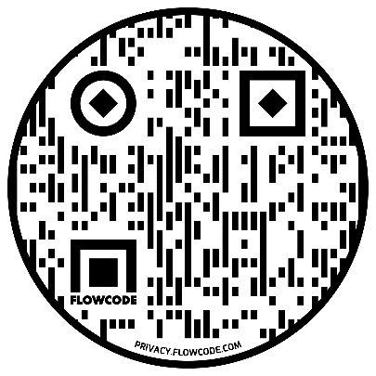

All the students who wish to appear for the exam must register themselves before 12:00 of 22nd October, 2020. The link will be closed after that.
If some student has backlog in any subjects of old syllabus and if he/she wish to give exam of that subject, he/she may contact HoD of the respective department.
The detailed timetable with date and time of subjects will be announced on 24th October, 2020.

